Group 10 Research Report

Executive Summary:

1. **Introduction**
2. **Recommendation(s)**
3. **Discussion**

* *Paid time to learn*
* *Time to grow as a team*
* *Workshops to practice and learn new skills*
* *Bonus for learning new skills*

1. **Graph**
2. **Conclusion**
3. **References**

Research Report

1. **Introduction:**

Hello Mr. Steven, we are writing from the IT department with a few recommendations for changes that could be implemented to increase productivity and employee morale. It has been a few years since the department was given a chance to train and learn new skills as a result almost all the department does not have the skills to increase our efficiency. As it stands both our systems and our skills are outdated, there are more effective systems that could be used to save money, but we lack the expertise to use the newer systems. The security system is also out of date and the current staff do not have the knowledge to upgrade it. This could pose a security risk, information could be lost or leaked. Some members of the department do not have the time to learn outside work and others do not have the desire to learn on their own time. Our recommendations could prevent that and increase savings in the longer term.

1. **Recommendation(s):**

We have some recommendations on how you can improve our working conditions. We have put them into a list:

* Paid time to learn.
* Time to grow as a team.
* Opportunities to use new skills.
* Workshops to practice and learn new skills.
* Bonus for learning new skills.

1. **Discussion:**

According to the above suggestions, we gave a detailed explanation:

* ***Paid time to learn:***

Our first recommendation is paid time to learn and develop new skills, as these new skills could prove useful for the company in the future. According to Global Knowledge (2020), “…especially as a lack of necessary skills can be credited for increased employee stress, development and deployment delays, and increased operating costs.” (para.12). Employees lacking needed skills is costly for both the employee and the employer. The cost of time and hours can be 416 hours and over $22000 per employee, per year (Global Knowledge, 2020, 12 Challenges Facing IT Professionals, para. 13). As seen there ensuring your IT staff have paid time to work on acquiring the needed skills can be cheaper and more time effective then not giving time for them to learn. It can also be a matter of cyber security, if the IT staff do not have the time to learn about new technologies or techniques, they may not be able to fend off a cyber attack from someone who does have current and developed skills. Giving paid time to learn and develop skills is a great way to keep staff who know your systems well as well as any future problems that may arise from those systems, “Ninety-one percent of unsatisfied employees are likely to pursue alternative employment” (Global Knowledge, 2020, 12 Challenges Facing IT Professionals, para. 30). With IT jobs readily available if employees are not content there is little reason to prevent them from looking for new employment. As touched on earlier a lack of skills can result in employee stress and dissatisfaction in their work which could result in them leaving. In conclusion, we recommend that you give paid time to learn and develop new skills as it is cheaper more time efficient and shows that you care about your employees and their futures.

* ***Time to grow as a team:***

Our second recommendation is giving the IT staff a time to get to know each other so they can more work as a team more effectively. Teams are more effective than a group of individuals as “each member brings a unique combination of skills, talents, experience, and education their combined efforts make the team synergistic” (Smith et al. 2019, 11.1.0 para. 2). When facing a problem, a group of individuals may not share perspectives and as a result may struggle to fix the problem as each person may have only a part of the solution or understanding of the problem. When an effective team encounters a problem or a challenge they can use their array of skills and perspectives in tandem to overcome it. An effective team is “more than the sum of its parts” (Smith et al. 2019, 11.1.0 para. 2). A team takes time to build, the people take time to understand their role in this team and the roles of their teammates. They take time to get to know them and understand how they communicate. Communication is one of the most important parts of a team and everybody communicates in different ways, failing to understand how your teammates communicate could lead to wrong information being used or a lot of time wasted as they team tries to get on the same page. Giving time and activities to build a team out of the current IT team while we are not forced into a time sensitive situation where a communication breakdown could mean the difference between success and failure could save time and money. Therefore, we recommend that you give time and activities to start building teamwork in the IT department.

* ***Workshops to practice and learn new skills:***

A workshop is an academic conference where scholars in related fields gather under a specific topic to publish and discuss the results. The scale can large or small, and special lectures, research reports, and social activities will be arranged. Workshops are one of the main methods for employees to learn new technologies. The workshops will introduce some new ideas and technologies to inspire employees to further explore or learn. No matter is a collision of ideas or the introduction of new technologies will undoubtedly improve the company’s technical and the employees’ own technical level. Establishing new relationships and getting to know new relationships are important for personal growth, and even more important for the development of the company. The workshop will provide employees with the best opportunity to meet other people with common interests. Attending workshops is one of the best ways to create a network of relationships. Of course, this does not guarantee that employees will get acquainted with more relationships, but it will never hurt to try.

* ***Bonus for learning new skills:***

“We’ve all heard the expression about the carrot and the stick when it comes to motivation. In short, by dangling a carrot in front of a rabbit’s face, it’s possible to motivate them to follow a specific path with the ultimate goal of getting the reward – the carrot.” (Kristen Hamlin, 2019, The Role of a Reward in Employee Motivation, para. 1). Bonuses are a supplement to the basic salary of employees. They can also be regarded as rewards. They are remuneration paid to employees for contributions beyond the basic work requirements. The establishment of Bonus for learning new skills in order to enable employees to improve their ideas of learning new technologies is also a recognition of those who have worked hard. This incentive can be paid to employees a certain amount of bonus in addition to the normal basic salary. The establishment of a bonus system for learning new technologies by an enterprise is to closely link the renewal and iteration of enterprise technology with the personal income of employees through the evaluation of the proficiency of new knowledge by employees.

1. **Graph:**

Meanwhile we also have a piece of data that shows the benefits of these recommendations, please see the Figure 1 below:

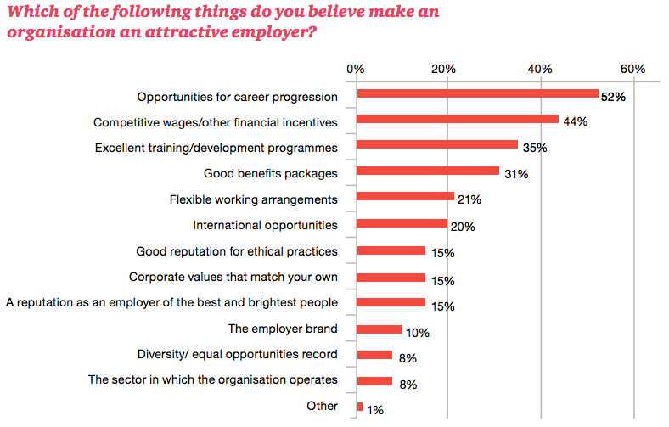

1. **Conclusion:**

Overall, these recommendations would make the IT department more effective and improve employee morale. New skills and technology could improve security and efficiency. Improving employee morale means that senior staff who know the company’s current systems and infrastructure well. We ask that ask some of these recommendations get implemented so that the IT department can continue help you the future

**References:**

*12 challenges facing IT professionals*. Top 12 Biggest Challenges Facing IT Professionals in 2020 | Global Knowledge. (n.d.). Retrieved December 11, 2021, from https://www.globalknowledge.com/us-en/resources/resource-library/articles/12-challenges-facing-it-professionals/.

Hamlin, K. (2019, March 20). *The role of a reward in employee motivation*. Small Business - Chron.com. Retrieved December 11, 2021, from https://smallbusiness.chron.com/role-reward-employee-motivation-18814.html.

*How to recognize and reward millennial employees*. Ambition. (n.d.). Retrieved December 11, 2021, from https://ambition.com/blog/entry/2016-05-15-guide-millennial-employee-recognition-and-rewards/.

Smith, J., Ashman, M., eCampusOntario, Dunphy, B., & Stracuzzi, A. (2019). *Professional Communications* (1st ed.). eCampus Pressbooks.